TechCrush Cybersecurity Class Assignment 2

You receive a Hex code in this format. Decode it to find the correct plain text.

2d 20 2e 2e 2e 2e 20 2e 2e 20 2e 2e 2e 0a 2e 2e 20 2e 2e 2e 0a 2e 2d 0a 2e 2d 2d 20 2e 2d 20 2d 2e 2d 2d 0a 2d 2e 2e 20 2d 2d 2d 20 2e 2e 2d 20 2d 2e 2e 2e 20 2e 2d 2e 2e 20 2e 0a 2e 20 2d 2e 20 2d 2e 2d 2e 20 2e 2d 2e 20 2d 2e 2d 2d 20 2e 2d 2d 2e 20 2d 20 2e 2e 20 2d 2d 2d 20 2d 2e 0a 2d 2e 2d 2e 20 2e 2d 20 2d 2e 0a 2d 2e 2e 2e 20 2e 0a 2d 2e 2e 20 2d 2d 2d 20 2d 2e 20 2e 20 2e 2d 2e 2d 2e 2d

You are required to submit:
The correct plain text.
The encryption algorithms used.
A screenshot of the entire page, showing how you got your result.

ANSWER

I started by opening a Cyberchef.io tool,
I searched through Operations and saw the Algorithm “From Hex” from the hint I got from the Assignment question.
See below the screenshot

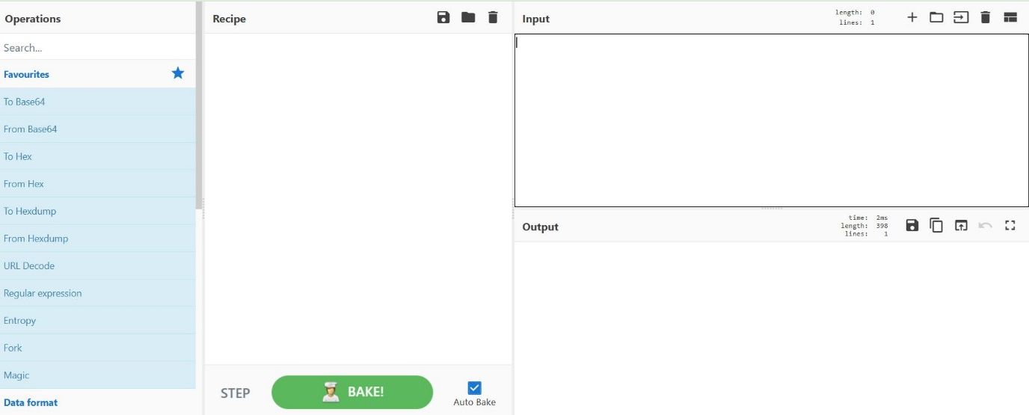

I then copied the ciper text and paste it in the Input column ready for the first level of decoding. And after then I double clicked the algorithm “From Hex” in which the input “ciper text” had an outcome in the output “alphanumeric” as an outcome. See screenshot below

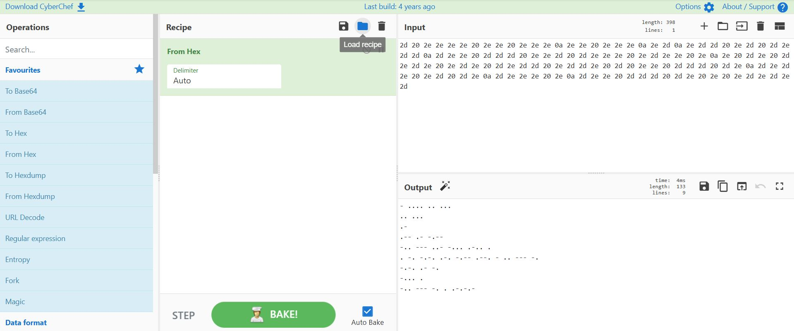

I now checked through Operations again searching for how I can decode alphanumerics. Then, I saw under Encryption/Encoding “From morse code” and I double clicked the algorithm “From morse code” and the alphanumerics were all converted to “Plain text”. See the screenshot below.

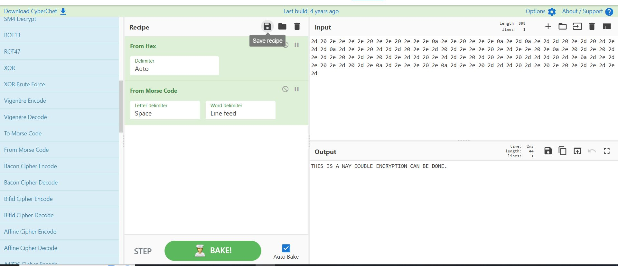

Finally, I have the plain text to be “THIS IS A WAY DOUBLE ENCRYPTION CAN BE DONE”.

